Gautschi's inequality

Intro

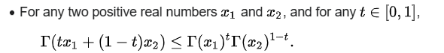

Substuting them with

$$x_{1}$$ = $$x+s$$

$$x_{2}$$ = $$x+s+1$$

$$t$$ = $$s$$

We have that



Then we divide two above inequalities, getting

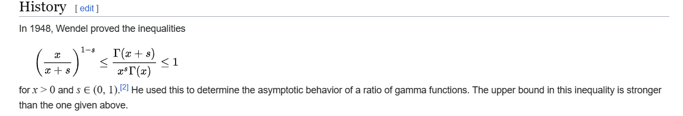

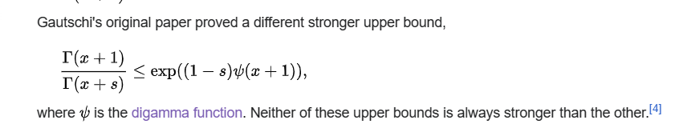

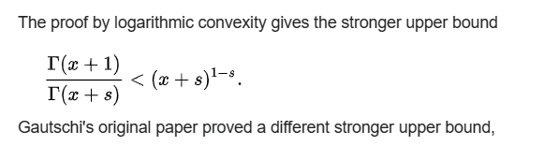

Ref

[Gautschi's inequality - Wikipedia](https://en.wikipedia.org/wiki/Gautschi%27s_inequality)